MINUTES
DECATUR COUNTY BOARD OF COMMISSIONERS
COMMISSIONERS' BOARD ROOM
PUBLIC HEARING
BUDGET AND MILLAGE RATE
TUESDAY, JULY 23, 2013 11:00 AM
PRESENT: VICE CHAIRMAN FRANK LOEFFLER, COMMISSIONER JAN GODWIN, COMMISSIONER DENNIS BRINSON, COUNTY ADMINISTRATOR GARY BREEDLOVE, COUNTY ATTORNEY BROWN MOSELEY AND COUNTY CLERK BEVERLY KING.
Vice Chairman Loeffler called the public hearing on the budget and millage rate to order at 11:00 a.m. After the call to order, Vice Chairman Loeffler stated the purpose of the public hearing was to allow the citizens of Decatur County to express their concerns related to the proposed budget and millage rate. Vice Chairman Loeffler opened the floor for discussion.
Vice Chairman Loeffler recognized Ray Brock. Mr. Brock asked the Board to consider the citizens of Decatur County when debating on whether to increase the millage rate resulting in higher property taxes. Mr. Brock stated he didn't believe the County should balance the budget on the backs of the citizens' of Decatur County.
Commissioners Godwin and Brinson thanked everyone for coming to the public hearing and encouraged everyone to participate in the public hearings to express their concerns. Vice Chairman Loeffler stated he was very disappointed in the amount of citizens that attended this public hearing on such an important issue as the county budget and millage rate.
There being no more participation, the meeting was adjourned.
Approved:
Attest:

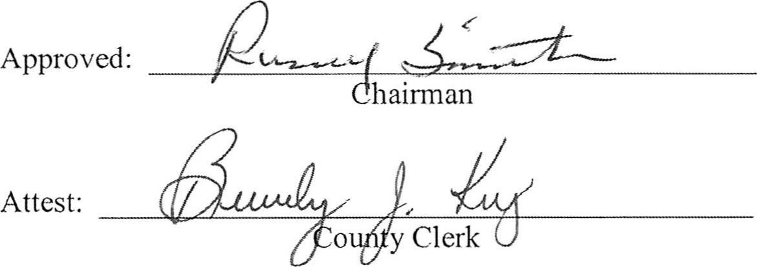
MINUTES
DECATUR COUNTY BOARD OF COMMISSIONERS
COMMISSIONERS' BOARD ROOM
PUBLIC HEARING
BUDGET AND MILLAGE RATE
TUESDAY, JULY 23, 2013 1:00 PM
PRESENT: CHAIRMAN RUSSELL SMITH, VICE CHAIRMAN FRANK LOEFFLER, COMMISSIONER DR. BUTCH MOSELY, COMMISSIONER JAN GODWIN, COMMISSIONER DENNIS BRINSON, COUNTY ADMINISTRATOR GARY BREEDLOVE, COUNTY ATTORNEY BROWN MOSELEY, COUNTY CLERK BEVERLY KING AND NEWS REPORTER JEFF FINLEY.
Chairman Smith called the public hearing on the budget and millage rate to order at 1:00 p.m. After the call to order, Commissioner Dennis Brinson gave the invocation and all those assembled pledged allegiance to the flag of the United States of America.
Chairman Smith opened the floor for discussion.
There was no public participation.
Commissioner Brinson thanked everyone for coming. Vice Chairman Loeffler stated he was very disappointed in the lack of interest from the citizens of Decatur County in such important matters as the budget and the millage rate.
Chairman Smith announced the third public hearing on the millage rate will be held July 30th at 6:00 p.m. Chairman Smith stated after this public hearing is adjourned the board will hold a special called meeting to approve the budget.
There being no more participation, the meeting was adjourned.

Approved: |  | 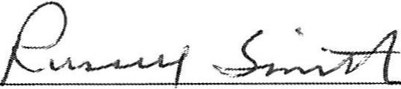

Chairman
Attest: | 