MINUTES
DECATUR COUNTY BOARD OF COMMISSIONERS
COMMISSIONERS' BOARD ROOM
PUBLIC HEARING
BUDGET AND MILLAGE RATE
TUESDAY, JULY 30, 2013 6:00 PM
PRESENT: CHAIRMAN RUSSELL SMITH, VICE CHAIRMAN FRANK LOEFFLER, COMMISSIONER DR. BUTCH MOSELY, COMMISSIONER JAN GODWIN, COMMISSIONER DENNIS BRINSON, COMMISSIONER OLIVER SELLERS, COUNTY ADMINISTRATOR GARY BREEDLOVE, COUNTY ATTORNEY BROWN MOSELEY, COUNTY CLERK BEVERLY KING AND NEWS REPORTER JEFF FINLEY.
Chairman Smith called the public hearing on the millage rate to order at 6:00 p.m.
Chairman Smith recognized County Administrator Gary Breedlove. Col. Breedlove explained in advertisements notifying the public of the proposed millage rate increase, it stated that the total increase would be 1.5 mills. This was the consensus of the board members after the completion of budget workshops in recent months. Col. Breedlove stated the county was notified that it would be rejected on its GEFA loan application unless it separately allocated 0.25 mills just for the GEFA loan. The county agreed to add on the 0.25 mills as a new tax. Col. Breedlove stated that the millage rate increase could be declared null and void by the state. Col. Breedlove explained that there may be a problem with the size of the public advertisements published in The Post Searchlight. He said the advertisement needed to be at least 30 square inches but it was not that large. Col. Breedlove stated the county used the same size advertisement last year without any issue. He said the county may have an opportunity to appeal, but if the state decides its advertisements were illegal, then the county may have to start the process over again. The county would have to readvertise the millage rate increase and hold three more public hearings. Col. Breedlove stated he thought that the county had an opportunity to appeal and show that we had no ill intent and that the wisest move is to continue with the proceedings today.
Chairman Smith opened the floor for discussion.
Chairman Smith recognized Ted Snell. Mr. Snell said that he believed the county needed to break bread with the City of Bainbridge and determine a way the county's 23 Industrial Park customers could connect with the city's existing sewer system. This would allow the county to eventually close the wastewater treatment plant saving money on needed improvements. Mr. Snell also stated that the county needs to seriously consider selling the landfill.
County Administrator Breedlove told Mr. Snell that the county's wastewater treatment plant engineer and previous county administrator did not believe that was a viable option. Col. Breedlove said that problems cited included the length of the pipe that would be required, as well as the difficulty in connecting the city's pipe to the county's pipe, because the diameters are different. The idea had been discussed in length two years ago but deemed an impractical solution.
Chairman Smith recognized Dewey Robinson. Mr. Robinson stated that he did not envy the commissioners' position because they had some difficult decisions to make. He stated that the county cannot borrow itself out of debt. Mr. Robinson said he still believed the county could find ways to cut expenses. Mr. Robinson stated it was the Board of Commissioner's responsibility to go back to the drawing board. He said the government has too many giveaway programs and we have to start using common sense.
Chairman Smith responded that the county had already made cuts and that this year's budget was smaller than the 2012-2013 budget, which in turn was smaller than the 2011-
Bill Nichols, a former county commissioner, said that he did not understand why Decatur County's population has remained steady over the years, and yet the county's budget and government's size have ballooned.
Attest: | 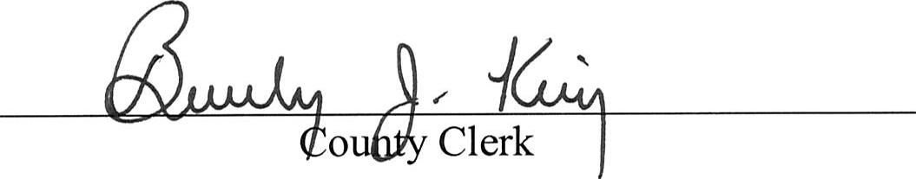

Discussions on ways to bring revenue to Decatur County were discussed such as a $.01 cent sales tax increase and Highway 27 upgrades.
There being no more participation, the meeting was adjourned.
Approved:
Chairman

