MINUTES
DECATUR COUNTY BOARD OF COMMISSIONERS
COMMISSIONERS' BOARD ROOM
TUESDAY, JUNE 25, 2013
PRESENT: CHAIRMAN RUSSELL SMITH, VICE CHAIRMAN FRANK LOEFFLER, COMMISSIONERS DR. BUTCH MOSELY, OLIVER SELLERS (BY PHONE), DENNIS BRINSON AND JAN GOD WIN, COUNTY ADMINISTRATOR GARY BREEDLOVE, COUNTY CLERK BEVERLY KING AND NEWS REPORTER JUSTIN SCHUVER.
INVOCATION AND PLEDGE OF ALLEGIANCE
Chairman Smith called the meeting to order at 7:00 p.m. After the call to order, Reverend Adren Bivens gave the invocation and all those assembled pledged allegiance to the flag of the United States of America.
AMENDMENTS / APPROVAL OF AGENDA
County Administrator Gary Breedlove asked the board to approve the following amendments to the agenda: Add Under Special Presentations, Sheriff Wiley Griffin for a Grant Approval; Under Old Business, Update on WWII Hangar Project; and Update on E911 Narrow Band Project. Vice Chairman Loeffler made a motion to approve the agenda with these amendments. Commissioner Brinson seconded the motion. A vote was taken and unanimously approved.
SPECIAL PRESENTATIONS
Chairman Smith recognized Charles Proctor. Mr. Proctor is with Gold Star Ambulance Service. Mr. Proctor introduced himself and presented the commissioners with a brief history of his company. Mr. Proctor stated his company was interested in bidding for the County's EMS service if the Decatur County decides to privatize the EMS service.
Chairman Smith recognized Sheriff Wiley Griffin. Sheriff Griffin recommended the Board approve a grant in Honor of Edward R. Burns, a deputy killed in the line of duty, in the amount of $9,000.00 to purchase an intoxication machine for the sheriffs department. Commissioner Mosely made a motion to approve this grant. Vice Chairman Loeffler seconded the motion. A vote was taken and unanimously approved.
PUBLIC PARTICIPATION
Chairman Smith recognized Ted Snell. Mr. Snell commended the County Administrator for being a realist. Mr. Snell stated a realist tends to view or represent things as they really are. Mr. Snell stated an increase in the millage rate is necessary for the county to survive and the County Administrator realizes this.
APPROVE MINUTES OF PREVIOUS MEETING
Commissioner Brinson made a motion to approve the minutes of the previous commissioners' meeting held June 11, 2013. Vice Chairman Loeffler seconded the motion. A vote was taken and unanimously approved.
Commissioner Brinson made a motion to approve the minutes of the budget workshop held June 11, 2013. Commissioner Mosely seconded the motion. Commissioner Mosely stated he was not present during the vote on cutting the funds for the Pines Golf Course and that the vote was not official because it was in a workshop. Commissioner Mosely stated he would not support cutting the funds from the golf course. A vote was taken and unanimously approved.
OLD BUSINESS
Update on Silver Lake. Chairman Smith recognized Matt Keel. Mr. Keel gave a brief update on the improvements made at Silver Lake and future plans on other projects. Mr. Keel and the commissioners discussed the advantages and disadvantages of being a partner in Silver Lake.
Update on Landfill. Chairman Smith recognized Jim Overman. Mr. Overman is one of the original members of the Solid Waste Advisory Committee. Mr. Overman recommended that the
county provide more frequent updates on the status of the landfill. Mr. Overman said it was important for the citizens of Decatur County to know how their investment is doing and that their interests are being kept at heart. Mr. Overman presented the board with a list of information that he requested be provided at least three days prior to the next commissioners' meeting and be included as an agenda item for discussion at that meeting.
Chairman Smith recognized County Administrator Breedlove. Col. Breedlove presented a map of the landfill and gave a brief update on the construction of cell 4. Col. Breedlove stated that two pieces of heavy equipment are needed to complete the construction in a timely manner. One is a tractor with an offset disc harrow and the other is an off-road dump truck. Col. Breedlove stated the dump truck will be a rental for approximately six months. The low bidder wasYancey Brothers with a bid of $6,800.00 per month. Col. Breedlove stated the existing county-owned equipment is not capable of effectively moving the kind of dirt at the landfill site. Vice Chairman Loeffler made a motion to approve the rental of the dump truck from Yancey Brothers. The motion failed for lack of a second.
Chairman Smith recognized Steven Wells. Mr. Wells stated he was appearing before the board to show his concern on a tax increase of any kind. Mr. Wells said the county should run their budget like a household runs its budget. Mr. Wells said he believed there were places where the county could cut expenditures and prevent raising taxes. Mr. Wells stated there were citizens in Decatur County that could not afford higher taxes without losing their homes.
Budget Draft — FY 2014. County Administrator Breedlove said that the proposed 2013-2014 budget included a cut of 8.7 percent across the board, compared to the 2012-2013 budget. Col. Breedlove stated that many of the county's expenditures are mandated by state and federal agencies and cannot be cut. Col. Breedlove stated the proposed budget is $1.4 million less than last year's budget, but even after those cuts, a millage rate increase will still be needed because of expected sales-tax revenue shortfalls. Col. Breedlove stated the decline in sales tax revenue is different from one month ago by approximately $800,000.
Sheriff Griffin stated he had cut approximately $800,000 from his budget and there was nothing else for him to cut. Sheriff Griffin stated his department went from 81 employees to 65 employees which he felt was a safety issue for the citizens of Decatur County.
WWII Hangar Update. County Administrator Breedlove stated the bids for the WWII hangar project were opened today and was in the process of negotiating an agreement with a company from Tallahassee to repair the roof and front of the building with the money that was available through the grant and money donated by a local citizen. Col. Breedlove stated the rest of the work will be phased out as the money becomes available.
Update on Narrow Band Radio Project. County Administrator Breedlove stated that last week the radio equipment for Decatur County was tested and completed. The equipment in Grady County is now being tested. Col. Breedlove stated he anticipated the new system to be converted over by next week.
NEW BUSINESS
Consider Approval of Contract between City of Cairo and DCCI. Chairman Smith recognized Warden Elijah McCoy. Warden McCoy told the board that the city of Cairo had recently asked him to provide a work crew of up to 12 inmates to clean up the city's parks and other public areas. Warden McCoy asked the Board to allow him to work with the County Attorney and the City of Cairo to draw up an agreement for the work crew. Warden McCoy stated the proposal would ask the city of Cairo to pay $46,263 a year for the work crew or about $3,855 per month. Warden McCoy stated the county will provide the salary for the certified correction officer who will watch over the work crew. The City of Cairo will handle all other expenses to include a vehicle to transport the inmates, all equipment needed, medical expenses that may be incurred by the work crew while performing these duties and any other emergency expenses. Warden McCoy stated the cost for a certified correction officer for this duty would cost the county approximately $34,000 in salary and benefits. Commissioner Mosely made a motion to approve this request from Warden McCoy. Vice Chairman Loeffler seconded the motion. A vote was taken and unanimously approved.
Consider Approval of Spending Resolution. County Administrator Breedlove stated this resolution will allow the county to operate at the current 2012-2013 budget funding levels until the proposed budget can be finalized. Col. Breedlove read aloud the resolution. Commissioner Mosely made a motion to approve this spending resolution. Vice Chairman Loeffler seconded the motion. A vote was taken and unanimously approved.
Landfill Tractor. County Administrator Breedlove stated that a tractor with an offset disc harrow was needed to complete the construction of cell 4 in a timely manner. Col. Breedlove stated that Ag-Pro of Bainbridge was the low bidder at $67,250.00 out of the three bids that were received. Col. Breedlove stated the cost of this equipment was included in the GEFA loan the county had taken to construct cell 4. Col. Breedlove stated this tractor could be used for additional construction of cells at the landfill. Commissioner Godwin stated that it didn't look like the companies that bid on this tractor were bidding on the same size of equipment. It appears that one company bid on a larger tractor than the other ones. Commissioner Godwin made a motion to table this issue until the commissioners had more time to review it. Commissioner Mosely seconded the motion. Commissioner Mosely stated their agenda books did not contain any documents pertaining to this purchase. Commissioner Mosely said that he believed the county should look at other revenues rather than buying a new tractor. Commissioner Mosely stated that used tractors are regularly sold at equipment sales at a significant bargain. Commissioner Sellers agreed that the county should look into buying used equipment. A vote was taken and approved with a 5 to 1 vote. Chairman Smith, Commissioner Mosely, Commissioner Sellers, Commissioner Brinson and Commissioner Godwin voted in favor. Vice Chairman Loeffler opposed.
Attest: | 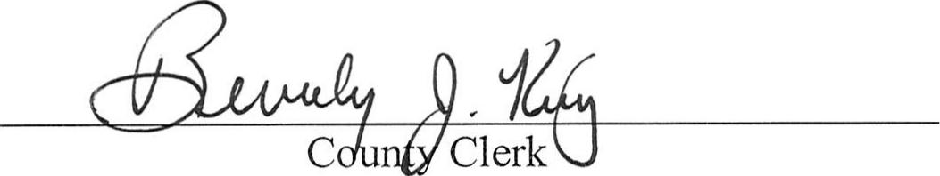

Regional Commission Membership. County Administrator Breedlove stated that he received a memo from the Regional Commission that the county's membership was being increased by 10%. The commissioners discussed if it was mandatory or not to be a member of the Regional Commission. Commissioner Mosely made a motion to table this issue until further information could be obtained. Vice Chairman Loeffler seconded the motion. A vote was taken and unanimously approved.
COMMISSIONERS' REMARKS
Commissioner Godwin thanked Attapulgus Mayor Johnny Medley and all the citizens present for coming to the commissioners' meeting and expressing their concerns.
Commissioner Mosely made a motion to add personnel to the executive session to discuss a board appointment. Commissioner Godwin seconded the motion. A vote was taken and unanimously approved.
Chairman Smith recognized Roland Hebert, manager of the Pines Golf Course. Mr. Hebert spoke of concerns of Decatur County cutting the funds for the Pines Golf Course. Mr. Hebert stated the golf course was the only recreational activity offered for the citizens that the county now funds.
Attapulgus Mayor Johnny Medley spoke about providing services and recreational activities for the citizens of Decatur County. Mr. Medley said he thought the funds Decatur County provided for the Pines Golf Course was well spent.
Commissioner Mosely made a motion to go into executive session to discuss personnel and real estate. Commissioner Brinson seconded the motion. A vote was taken and unanimously approved.
After executive session the Commissioners assembled back in the board room. Commissioner Mosely made a motion to go into regular session. Vice Chairman Loeffler seconded the motion. A vote was taken and unanimously approved.
Chairman Smith stated the board discussed a personnel issue and a real estate matter. Chairman Smith stated no action was taken at this time.
There being no further business, the meeting, on motion by Commissioner Mosely, was duly adjourned. Commissioner Godwin seconded the motion. A vote was taken and unanimously approved.
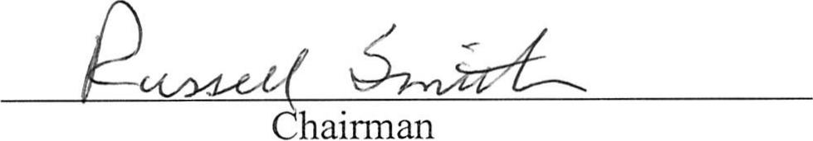
Approved:

