MINUTES
DECATUR COUNTY BOARD OF COMMISSIONERS
COMMISSIONERS' BOARD ROOM
SPECIAL CALLED MEETING
BUDGET APPROVAL
TUESDAY, JULY 23, 2013 1:10 PM
PRESENT: CHAIRMAN RUSSELL SMITH, VICE CHAIRMAN FRANK LOEFFLER, COMMISSIONER DR. BUTCH MOSELY, COMMISSIONER OLIVER SELLERS (BY PHONE) COMMISSIONER JAN GOD WIN, COMMISSIONER DENNIS BRINSON, COUNTY ADMINISTRATOR GARY BREEDLOVE, COUNTY ATTORNEY BROWN MOSELEY, COUNTY CLERK BEVERLY KING AND NEWS EDITOR JUSTIN SHUVER.
Chairman Smith called the special called meeting on the budget to order at 1:10 p.m. After the call to order, Commissioner Dennis Brinson gave the invocation and all those assembled pledged allegiance to the flag of the United States of America.
Chairman Smith recognized County Administrator Gary Breedlove. Col. Breedlove gave a brief presentation on the County's debt burden, the anticipated GEFA loans, the landfill cell construction and the waste water treatment plant upgrades. Col. Breedlove gave mil rate comparison with surrounding counties and a recommendation of a 3.25 mil rate increase to the Board for their consideration.
Chairman Smith recognized Hebert Roland, manager of the Pines Golf Course. Mr. Roland asked the Board to please reconsider closing the golf course.
Chairman Smith recognized David Howell. Mr. Howell spoke in support of keeping the golf course open. Mr. Howell stated it was the only recreational activity the county now supports.
Commissioner Mosely stated he didn't feel good about the situation with the funds being cut for recreation from the City and if the County cuts the funds from the golf course it would not be supporting any recreational activity at all. A brief discussion followed.
The Board voted on the following items on the budget:
- County Treasurer Position ($10,000.00) Vice Chairman Loeffler made a motion to take the initiative to eliminate the County Treasurer Position at the proper legal time through a resolution.
Commissioner Brinson seconded the motion. A vote was taken and unanimously approved.
- Golf Course ($48,000.00)
Commissioner Sellers made a motion to put the funds back into the budget for The Pines Golf Course.
Commissioner Brinson seconded the motion.
A vote was taken and approved with a 4 to 2 vote
Commissioners Godwin, Brinson, Mosely and Sellers voted in favor.
Chairman Smith and Vice Chairman Loeffler opposed.
- BassPro ($9,000.00)
Vice Chairman Loeffler made a motion to remove the BassPro funds from the budget. Commissioner Brinson seconded the motion.
A vote was taken and failed with a 3 to 3 vote.
Vice Chairman Loeffler, Chairman Smith and Commissioner Brinson voted in favor. Commissioners Godwin, Sellers and Mosely opposed.
- Medical Benefits ($25,000.00)
Vice Chairman Loeffler made a motion to eliminate funding for insurance for elected officials at the appropriate legal time through a resolution. (County Treasurer, County Coroner, State Solicitor and State Judge)
Commissioner Brinson seconded the motion.
A vote was taken and unanimously approved.
Attest: | 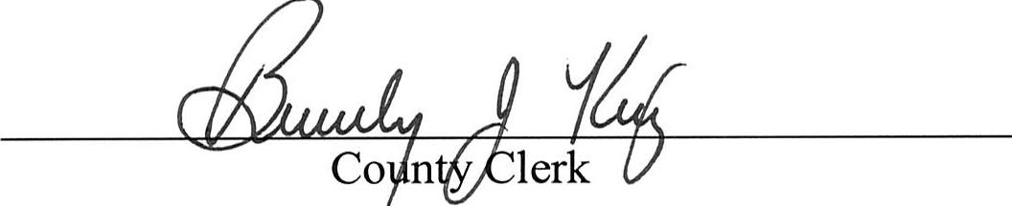

- EMS Privatization ($200,000.00)
Vice Chairman Loeffler made a motion to direct the County Administrator to advertise a RFP to privatize Decatur County EMS.
Commissioner Mosely seconded the motion.
Vice Chairman Loeffler amended his motion to add a RFP to solicit bids to privatize Decatur County EMS and Decatur County EMS with an adjacent county EMS. Commissioner Mosely seconded the amendment.
A vote was taken and approved with a 5 to 1 vote.
Chairman Smith, Vice Chairman Loeffler, Commissioners Brinson, Godwin and Mosely approved. Commissioner Sellers opposed.
- District Attorney ($5,000.00)
Vice Chairman Loeffler made a motion to eliminate the funding in the amount of $5,000.00 to the District Attorney from the budget.
Chairman Smith seconded the motion.
A vote was taken and failed with a 2 to 4 vote.
Vice Chairman Loeffler and Chairman Smith approved. Commissioners Godwin, Brinson, Mosely and Sellers opposed.
- Employee Medical ($10.00 per employee per month)
Commissioner Godwin made a motion to increase the employee's portion for health insurance to $50.00 per month per employee.
The motion failed for lack of a second.
Vice Chairman Loeffler made a motion to increase the employee's portion for health insurance by $10.00 per month per employee making the amount the employee pays per month $30.00.
Commissioner Sellers seconded the motion.
A vote was taken and approved with a 4 to 2 vote.
Vice Chairman Loeffler, Commissioners Godwin, Mosely and Sellers approved. Chairman Smith and Commissioner Brinson opposed.
- No Buy Backs FY14 ($240,000.00)
Commissioner Sellers made a motion to suspend the buy-backs in the FY14 budget. Vice Chairman Loeffler seconded the motion.
A vote was taken and unanimously approved.
Commissioner Mosely made a motion to instruct the proper staff to revisit employee PTO time, sick time and holidays. A brief discussion followed. Chairman Smith stated this special called meeting was to approve the budget. Commissioner Mosely withdrew his motion.
Commissioner Brinson made a motion to approve the budget resolution with the changes approved in this meeting.
Commissioner Sellers seconded the motion.
A vote was taken and approved with a 5 to 1 vote
Vice Chairman Loeffler, Commissioners Godwin, Brinson, Mosely and Sellers approved. Chairman Smith opposed.
Chairman Smith stated he could not approve the budget with the county keeping a $48,000 subsidy for the golf course. Chairman Smith said he has a responsibility to listen to the citizens in his district.
There being no further business, the meeting was adjourned.
Approved:
Chairman

