Decatur County Board of Commissioners
Budget Workshop
May 14, 2013
11:00 A.M.
Present: Chairman Russell Smith, Vice Chairman Frank Loeffler, Commissioner Jan Godwin and Commissioner Dennis Brinson, County Administrator Gary Breedlove, County Clerk Beverly King, Accounting Supervisor Michelle West and News Editor Jeff Finley.
County Administrator Breedlove gave a sample revenue projection of the following:
SPLOST V:  - Budget Estimate  - June 2013 Estimate  - FY 2013 Shortfall  LOST:  - Budget Estimate  - June 2013 Estimate  - FY 2013 Shortfall  Factors Effecting SPLOST / LOST:  - Economy  - FICA 2%  - Gate Cards  - Internet Sales  - Tax Evasion  Landfill:  - Budget Estimate  - June 2013 Estimate  - FY 2013 Shortfall  EMS Ambulance:  - Budget Estimate  - June 2013 Estimate  - FY 2013 Shortfall | $2,676,006  $2,169,858  $ 506,148  $2,683,793  $2,414,476  $ 269,316  $2,500,555  $2,432,616  $ 67,384  $ 900,000  $ 770,000  $ 130,000 | Total for all (4) $972,848

Risky Assumptions:
- No significant contingencies
- No significant financial bind from Obama Care
- Less Personnel (27) positions

Fiscal Year 2014 Budget Impact Areas: Recommended Cuts:
- Health Department
- Georgia Forestry Commission
- LIFE
- Bikefest / Bass Pro
- Climax Fire Payment
- Fire Department Insurance
- Medical Benefits for Part Time Total
Prospective Cuts:
- Privatize EMS
- District Attorney
- Public Defender
- Golf Course
Total
$ 50,000 $ 8,000 $ 10,000 $ 12,000 $3,000 Bikefest $9,000 Bass Pro
$ 10,000 Volunteer Fire Truck Payment
Golf Course Manager, Mr. Hubert Roland, gave the commissioners a brief background on the golf course.
$ 15,000 Separate Company for Workmen's Comp
$ 25,000 State Judge, State Solicitor, County Treasurer & Coroner $130,000
$200,000+ Workman's comp is also a cost factor
$ 5,000 $ 20,000 $ 40,000 $265,000+

Budget Delay:
Attested: | 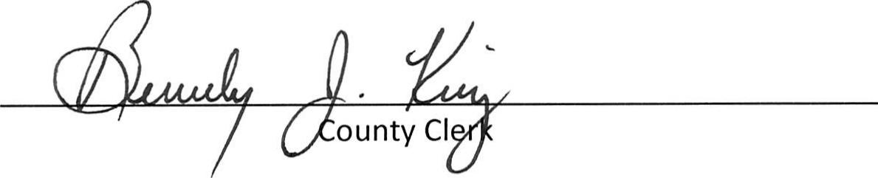

- E911 Telephone Upgrade $250,000 (July 2013 for FY 2015 —1st Pay July 2014)
Potential Revenue Areas:
- GEMA Reimbursements $ 75,000+ GEMA owes County
- Seminole Solid Waste $180,000 Gross Revenue
- Blakely / Early County Waste $250,000 Gross Revenue
Total $505,000+
Millage Rates:
- Increase millage rate for the County 3 mils
- Change .25 mils from the Industrial Development Authority back to the County
- 105 counties in Georgia are higher than our millage rate
Col. Breedlove gave some Millage Rate examples:
Home assessed at $100,000 "Tax Card Value":
Current property taxes from County @ 9.66 mil = $386.40
With this home value, each additional mil point = $40.00, (3) mil = $120.00
Calendar Year 2013 Budget Deficit:
- $3.8 million (largest factor $2.18 million TAN payment — December 2012)
- $1.0 Calendar Year 2013 Budget Cuts
- $2.8 Remaining Deficit
- $2.6 Millage Change @ 3.25 mils
- $200,000 Deficit Balance — Need TAN note for cash flow
Calendar Year 2014 Budget Deficit:
- $1.8 Million ($1.6 million for 2014 + 200,000 from December taxes)
- $1.4 Million Budget Cuts
- $400,000 Deficit Balance — Need TAN note for cash flow
December 2014 taxes will bring approximately $2.2 million surplus into 2015
Calendar Year 2015:
Surplus in 2015 with well planned and effective SPLOST VI will allow us to:
- Pay down debt: we currently have 20 periodic payments + 2 GEFA loans in process of approval
- Debt pay down will enhance general fund
- Improve department operations / personnel / spending
- Improve infrastructure throughout the County
- Consider employee pay raises (July 2015 will be 7+ years since last employee raise)
Commissioners discussed ways to get information to the public (budget cuts)
Discussed dates for another work session
Mr. Jeff Finley suggested the Board of Commissioners have "called meetings" in the commissioner's room rather than "work sessions" in the conference room and perhaps show slides.
Col. Breedlove said that decisions needed to be made as soon as possible. Col. Breedlove stated a decision about the
millage rates needed to be made in order to complete the budget process and move forward with all other business..
Approved: | 0‘-t-i-s-e-t1 | _{..,s;}....._{,...At.}  Chairman

