Decatur County Board of Commissioners
Budget Workshop
June 11, 2013
10:30 AM
Present: Chairman Russell Smith, Vice Chairman Frank Loeffler, Commissioners Jan Godwin. Dr. Butch Mosely, Oliver Sellers and Dennis Brinson, County Administrator Gary Breedlove, Accounting Supervisor Michelle West, County Clerk Beverly King, E911 Director Tonya Griffin, Fire Chief Charlie McCann, Public Works Supervisor Dennis Medley and News Reporter Jeff Finley.
Chairman Russell Smith called the meeting to order at 10:30 a.m. Chairman Smith recognized County Administrator Gary Breedlove. Col. Breedlove gave a brief review of the following:
- Revenues in Sales Tax
- Revenues in SPLOST & LOST
- Over $800,000 below projected revenues
- Recalculated Budget Situation
Commissioner Godwin read aloud a letter from Forest Ranger Rodney Heard pertaining to services provided for Decatur County.
Commissioners discussed the following:
- Support to tourism and Development Authority
- 6.8 mil in budget cuts
- Positions eliminated from various departments
- Furlough Days
Warden Elijah McCoy discussed the different breed of inmates he is now receiving, the medical cost for inmates and the elimination of staff would possibly put his employees in danger.
Commissioners discussed the following recommended cuts:
• | Health Department | $50,000 | Commissioners agreed to cut
• | GA Forestry Commission | $8,000 | Commissioners agreed not to cut
• | LIFE | $10,000 | Commissioners agreed to cut
• | Bikefest | $3,000 | Commissioners agreed to cut
• | Bass Pro | $9,000 | Commissioners agreed not to cut
• | Climax Fire Truck Payment | $10,000 | Commissioners agreed not to cut
• | Fire Department Insurance | $15,000 | Commissioners agreed to change
• | Medical Benefits for P/T | $25,000 | Commissioners agreed not to cut
• | Privatize EMS | $200,000 | Still negotiating with companies
• | District Attorney | $5,000 | Commissioners agreed not to cut
• | Public Defender | $20,000 | Commissioners agreed to cut
• | Golf Course | $48,000 | Commissioners Godwin, Vice
Chairman Loeffler and Chairman Smith agreed to cut. Commissioners Sellers and Brinson opposed. Commissioner Mosely was not present during this time.
Col. Breedlove discussed the following expenditures the County faces:
- Waste Water Treatment Plant Upgrades
- Landfill Cell Construction
- Expenditures that cannot be cut, that are a necessity
- No contingencies for disasters
- Obama Care becoming effective in 2014
Col. Breedlove and commissioners discussed millage rate increase. The majority of the commissioners agreed to raise the millage 1.5. Commissioner Sellers was uncommitted and Commissioner Mosely was not present during this discussion.
Col. Breedlove stated with 1.5 mil increase, he didn't think a realistic budget could be put together. Col. Breedlove reminded the commissioners about the Standards and Poors report.
Attested: | 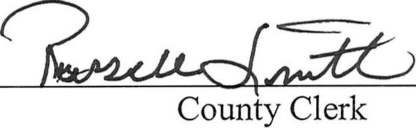

Approve: | 