PUBLIC NOTICE
AUDIT
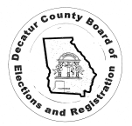
The Decatur County Board of Elections will be conducting an AUDIT of the Secretary of State contest pursuant to O.C.G.A. 21-2-498 and SEB Rule 183-1-15.04 that requires the Superintendent follow instructions issued by the Secretary of State on how to specifically conduct the audit.
The audit will begin on Wednesday December 14, 2022 at the Courthouse Annex @ 9am and will be completed by Thursday December 15, 2022, 11:59pm

This audit is open to members of the Public.

